Official league roster - Soccer
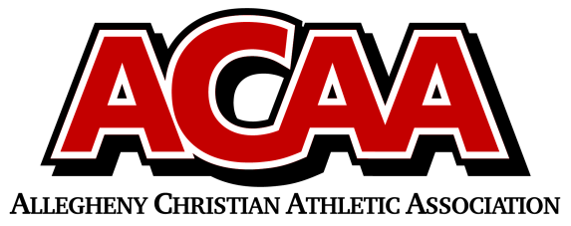

School Name: Johnstown Christian School
Team Colors: Royal Blue and White
Overall Wins ___ Losses ____ Ties ___
ACAA Wins ___ Losses ____ Ties ___ OPPONENT: __________________________
Date: _________
Number | Name | Year | Position | Homeschool
12 | Aaron Viscusi | 12 | d | no
11 | Mason Dean | 11 | m | no
18 | Elijah Williams | 11 | m | no
19 | Quan Freeman | 11 | m | no
17 | Jeremiah Taylor | 10 | g | no
4 | Jaydon Yoder | 9 | m | no
14 | Jacoby Jackson | 8 | d | no
5 | Matthew Blough | 8 | m/d/g | no
2 | Jeremiah Taylor | 8 | f/m | no
6 | Nathan Marsh | 8 | d/m | no
3 | Braydon Kibbi | 8 | f/m | no
9 | Dorin Cook | 8 | m/d | no
8 | Jacob Taylor | 12 | D | NO
1 | Levi DiGuardi | 7 | f/m | no
7 | Adam Habacker | 7 | f/m/d | no

Head Coach: Brian Grove
Asst. coach: David Sprankle
Asst. coach:

Official ACAA League Team Roster. to be submitted to the scorer’s table before each game.

